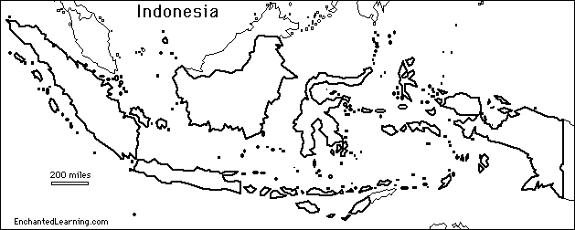

There are more than 17,500 islands in Indonesia.
Amazing facts about Indonesia
Indonesia has more than 140 active volcanoes.









Indonesia is home to some of the most endangered animals in the world.
Indonesia is home to the largest of all edible fruits, the jackfruit. It can weigh up to 30 kilograms!
Indonesia is home to the largest flower in the world, the Rafflesia.
There are more than 250 million people in Indonesia and around 150 million people live on the island of Java.
Java

